**Campus On Reels- Short Film Festival 2023**

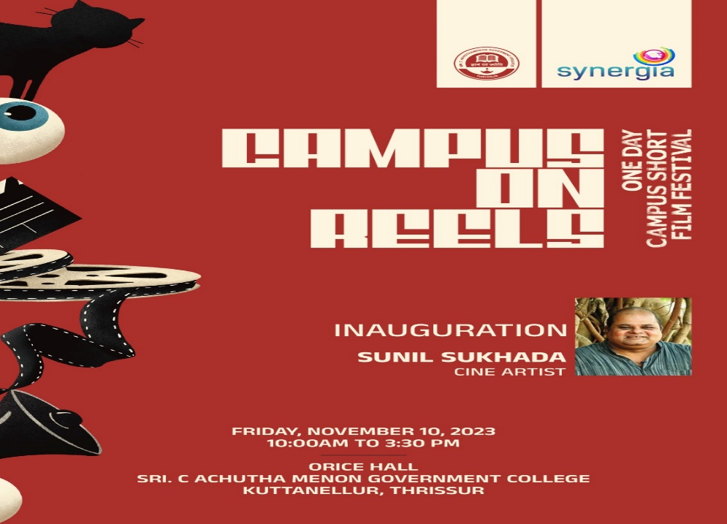

The Film Club organized a Campus Short Film Festival ‘ Campus On Reels’ , in collaboration with Synergia Campus for Youth Forum and Chetana college of Media and Advanced Studies, Thrissur on Friday November 10,2023 at 10 am at college ORICE hall. The festival was inaugurated by famous Malayalam cine and theatre artist Sunil Sukhada. The presidential address was given by the college principal Dr Manoj Kumar P S and the felicitations by Dr Fr Benny Benedict, Principal of Chetana College of Media and Advanced Studies, Thrissur. Razeena P R, Coordinator of Film Club gave the welcome speech and Dr Unnikrishnan T, Faculty Member of Film Club gave the vote of thanks. The festival showcased a diverse variety of selected short films made by students from campuses across the district and dealt with a variety of themes that was relevant in the contemporary social and political scenario.

**Programme pictures**

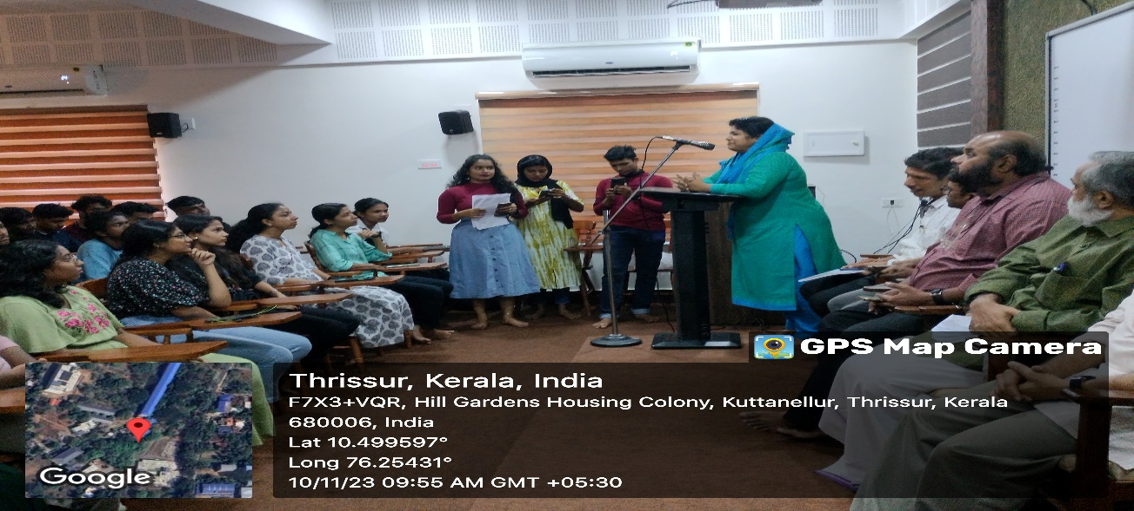

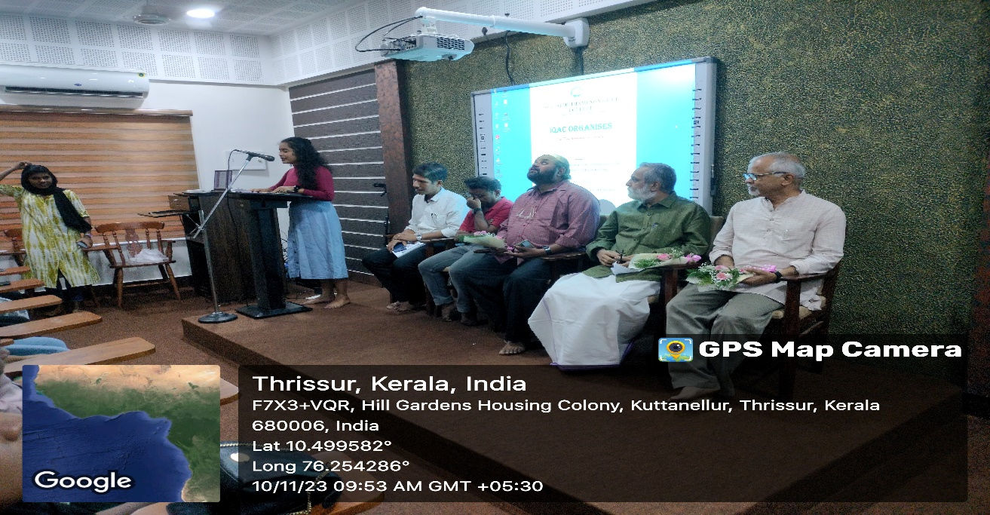

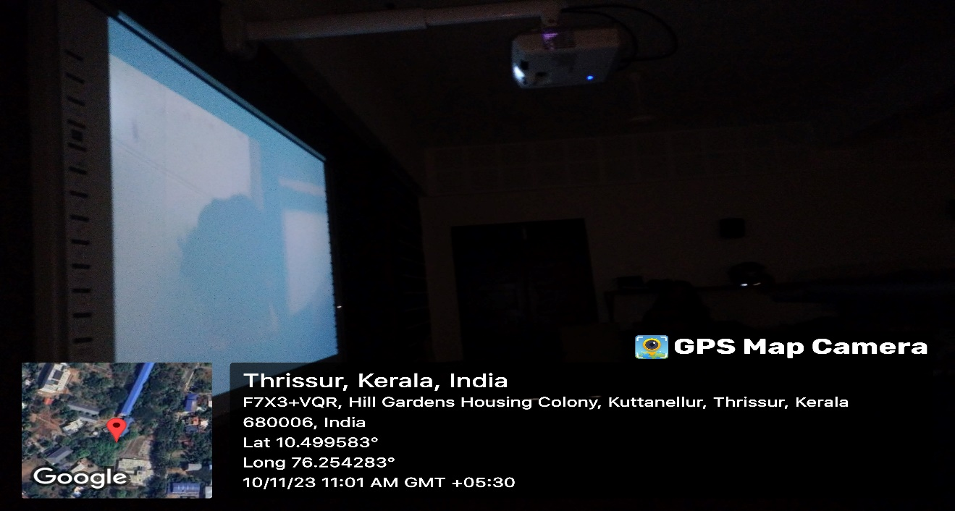

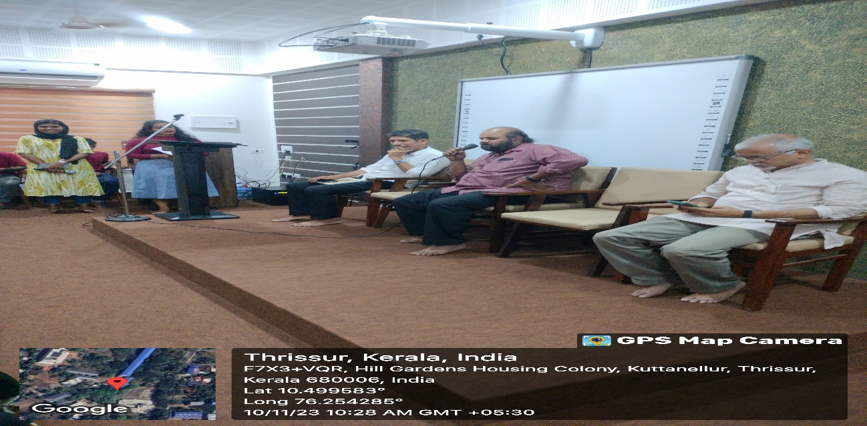

The programme was telecast on the local news channel TCV news and the link is given below

https://youtu.be/SA9icu67WXA?si=64B9VtlNPYEg9vJw